False Views of the Person of Christ

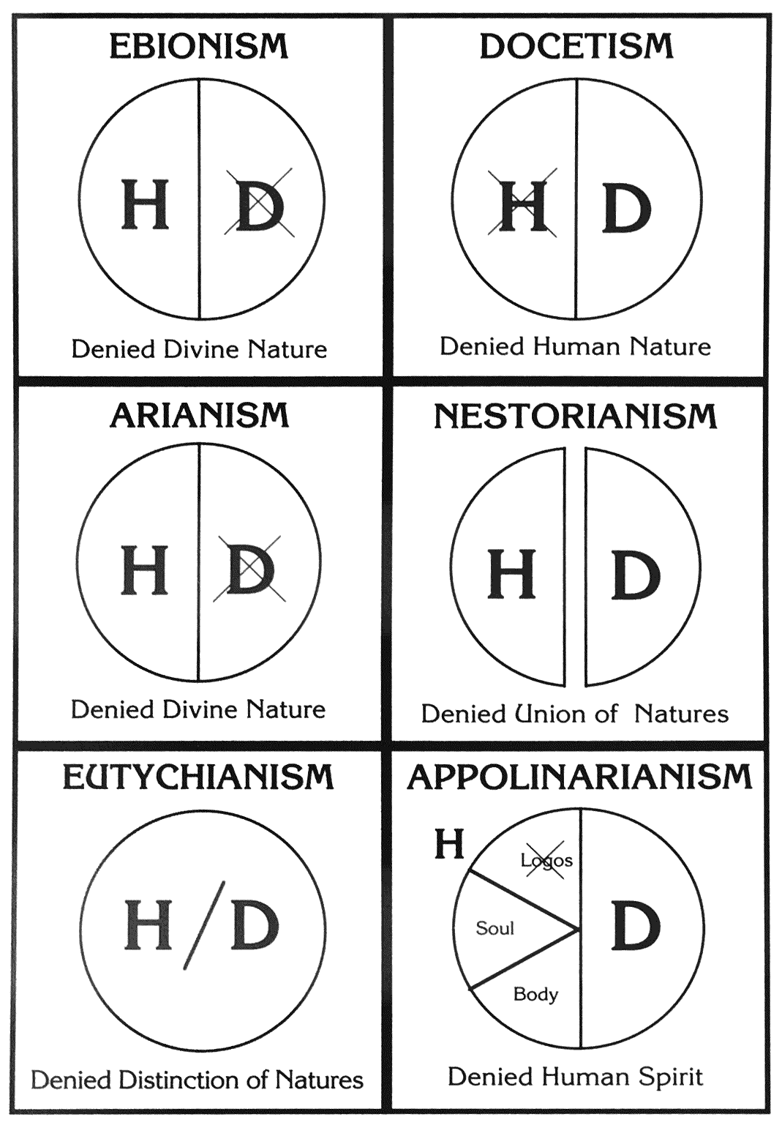
Late 1st Century
“Gnostics”
Affirmed Christ’s diety, not humanity
No official condemnation
_________
5th Century
Distinguished human Jesus, who died, from Divine Son, who cannot die. Denied Unity of Person
Answered in
Ephesus
_________
4th Century
Affirmed Christ’s diety and real humanness. The divine Logos took the place of the human mind.
Answered in
Antioch and
Constantinople
2nd Century
Promoted by
Judaizers
Monotheistic
No official condemnation

_________
4th Century
Christ is subordinate to the Father
Answered in
Nicea and
Constantinople
_________
5th Century
Maintained the unity of Christ’s person. Denied distinction of natures
Answered in
Chalcedon
Council of Nicea (325)
Council of Antioch (378)
Council of Constantinople (381)
Council of Ephesus (431)
Council of Chalcedon (451)

