My Father, Roger Laube, leading music on Mars Hill, circa 1980
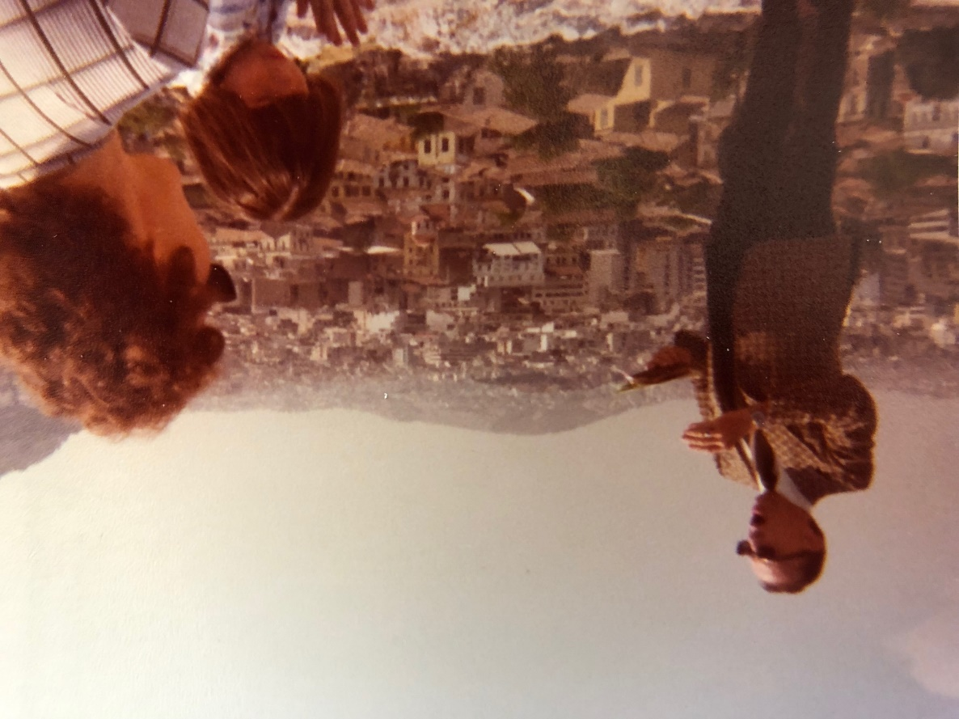
Me standing on the Parthenon in January 1977
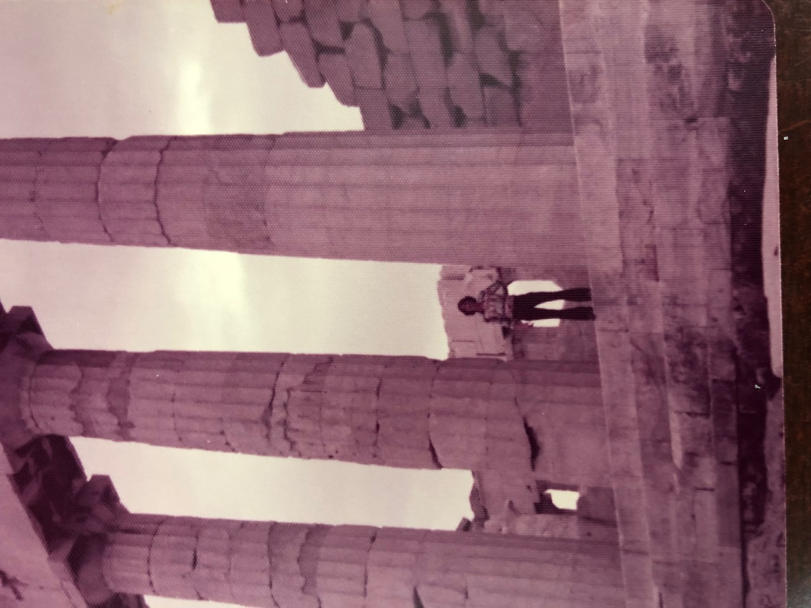
From Mars Hill looking North toward the ancient Agora (Marketplace) – (1977)
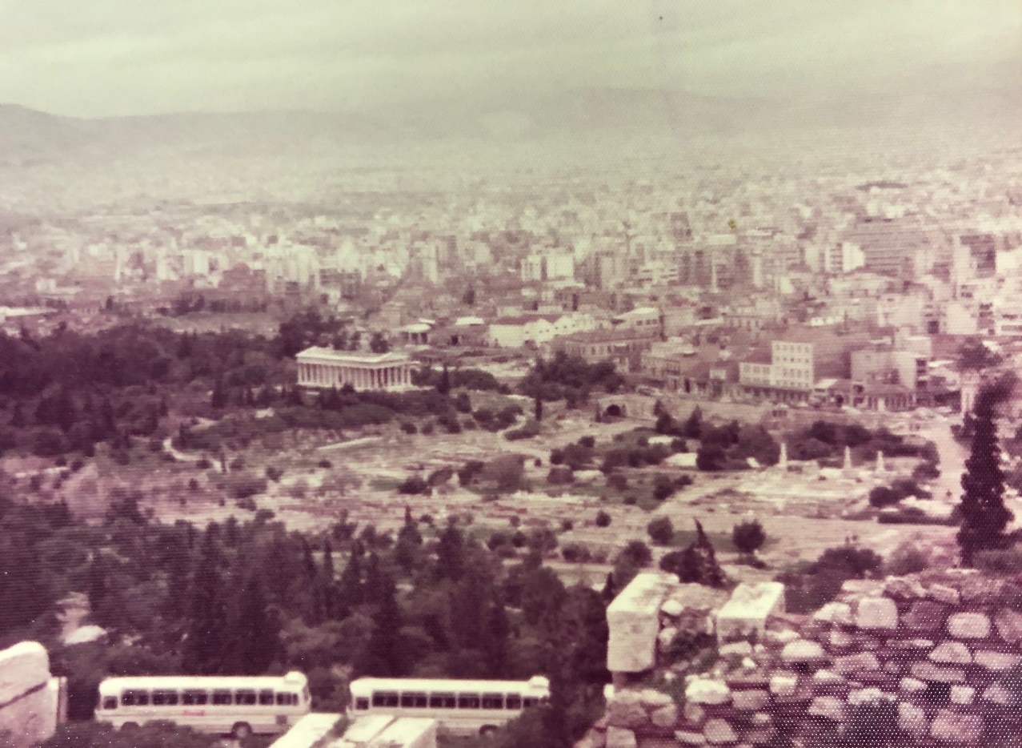

From Mars Hill looking SE up at Parthenon (1977)
