Paul’s First Missionary Journey

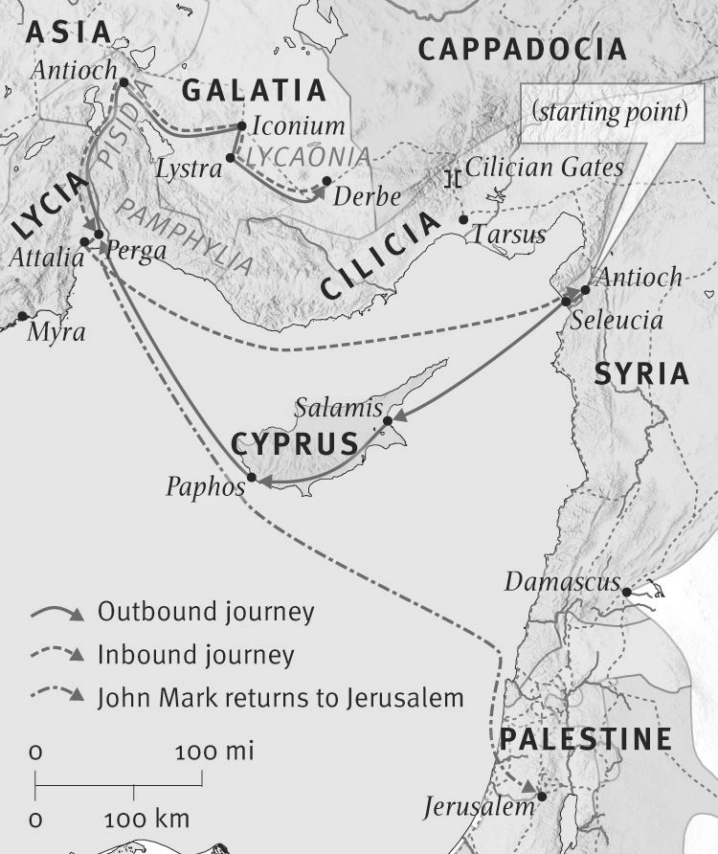
From ESV Bible Maps

