¹ Now concerning the collection for the saints: as I directed the churches of Galatia, so you also are to do. ² On the first day of every week, each of you is to put something aside and store it up, as he may prosper, so that there will be no collecting when I come. ³ And when I arrive, I will send those whom you accredit by letter to carry your gift to Jerusalem. ⁴ If it seems advisable that I should go also, they will accompany me.
Romans 15:24-27
²⁴ I hope to see you in passing as I go to Spain, and to be helped on my journey there by you, once I have enjoyed your company for a while. ²⁵ At present, however, I am going to Jerusalem bringing aid to the saints. ²⁶ For Macedonia and Achaia have been pleased to make some contribution for the poor among the saints at Jerusalem. ²⁷ For they were pleased to do it, and indeed they owe it to them. For if the Gentiles have come to share in their spiritual blessings, they ought also to be of service to them in material blessings.
Plans for Travel
⁵ I will visit you after passing through Macedonia, for I intend to pass through Macedonia, ⁶ and perhaps I will stay with you or even spend the winter, so that you may help me on my journey, wherever I go. ⁷ For I do not want to see you now just in passing. I hope to spend some time with you, if the Lord permits. ⁸ But I will stay in Ephesus until Pentecost, ⁹ for a wide door for effective work has opened to me, and there are many adversaries.

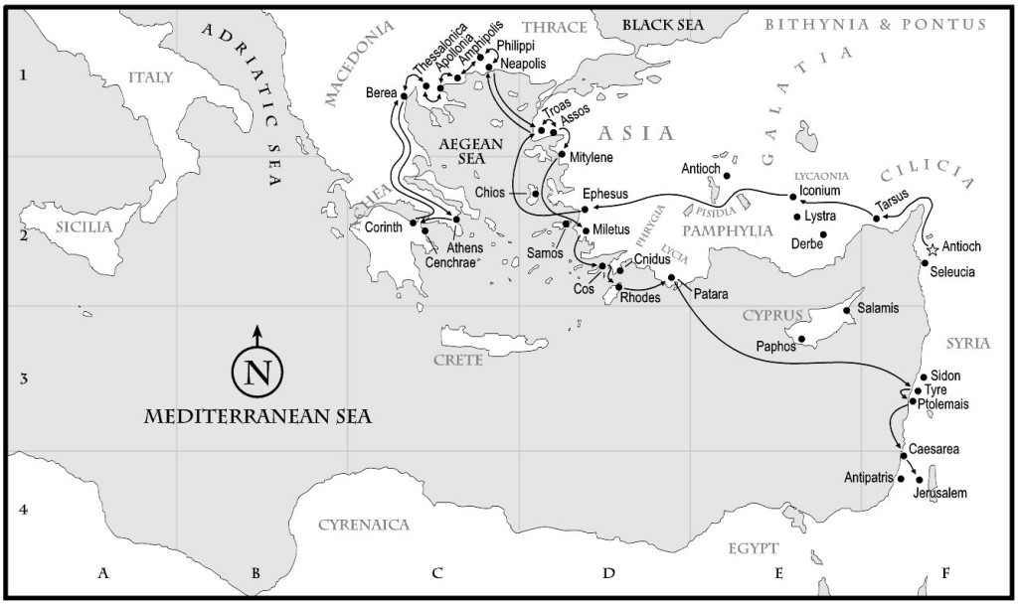

¹⁰ When Timothy comes, see that you put him at ease among you, for he is doing the work of the Lord, as I am. ¹¹ So let no one despise him. Help him on his way in peace, that he may return to me, for I am expecting him with the brothers.
1 Corinthians 4:17-21
¹⁷ That is why I sent you Timothy, my beloved and faithful child in the Lord, to remind you of my ways in Christ, as I teach them everywhere in every church. ¹⁸ Some are arrogant, as though I were not coming to you. ¹⁹ But I will come to you soon, if the Lord wills, and I will find out not the talk of these arrogant people but their power. ²⁰ For the kingdom of God does not consist in talk but in power. ²¹ What do you wish? Shall I come to you with a rod, or with love in a spirit of gentleness?

1 Timothy 4:12-14
¹² Let no one despise you for your youth, but set the believers an example in speech, in conduct, in love, in faith, in purity. ¹³ Until I come, devote yourself to the public reading of Scripture, to exhortation, to teaching. ¹⁴ Do not neglect the gift you have, which was given you by prophecy when the council of elders laid their hands on you.
Final Instructions
¹² Now concerning our brother Apollos, I strongly urged him to visit you with the other brothers, but it was not at all his will to come now. He will come when he has opportunity.
1 Corinthians 1:12-13
¹² What I mean is that each one of you says, “I follow Paul,” or “I follow Apollos,” or “I follow Cephas,” or “I follow Christ.” ¹³ Is Christ divided? Was Paul crucified for you? Or were you baptized in the name of Paul?
¹³ Be watchful, stand firm in the faith, act like men, be strong. ¹⁴ Let all that you do be done in love.
¹⁵ Now I urge you, brothers—you know that the household of Stephanas were the first converts in Achaia [1 Corinthians 1:16], and that they have devoted themselves to the service of the saints— ¹⁶ be subject to such as these, and to every fellow worker and laborer. ¹⁷ I rejoice at the coming of Stephanas and Fortunatus and Achaicus, because they have made up for your absence, ¹⁸ for they refreshed my spirit as well as yours. Give recognition to such people.

Greetings
¹⁹ The churches of Asia send you greetings. Aquila and Prisca, together with the church in their house, send you hearty greetings in the Lord. ²⁰ All the brothers send you greetings. Greet one another with a holy kiss.
²¹ I, Paul, write this greeting with my own hand. ²² If anyone has no love for the Lord, let him be accursed. Our Lord, come! ²³ The grace of the Lord Jesus be with you. ²⁴ My love be with you all in Christ Jesus. Amen.

Where in the Bible is the greatest chapter on the resurrection?
Where in the Bible is the greatest chapter on love?
Where in the Bible is the best section discussing the Spiritual Gifts?

