⁵ Now if anyone has caused pain, he has caused it not to me, but in some measure—not to put it too severely—to all of you. ⁶ For such a one, this punishment by the majority is enough, ⁷ so you should rather turn to forgive and comfort him, or he may be overwhelmed by excessive sorrow. ⁸ So I beg you to reaffirm your love for him. ⁹ For this is why I wrote, that I might test you and know whether you are obedient in everything. ¹⁰ Anyone whom you forgive, I also forgive. Indeed, what I have forgiven, if I have forgiven anything, has been for your sake in the presence of Christ, ¹¹ so that we would not be outwitted by Satan; for we are not ignorant of his designs.
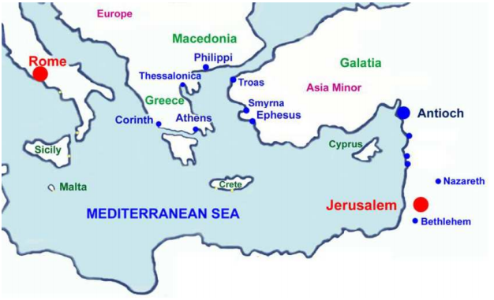
¹² When I came to Troas to preach the gospel of Christ, even though a door was opened for me in the Lord, ¹³ my spirit was not at rest because I did not find my brother Titus there. So I took leave of them and went on to Macedonia.

¹⁴ But thanks be to God, who in Christ always leads us in triumphal procession, and through us spreads the fragrance of the knowledge of him everywhere. ¹⁵ For we are the aroma of Christ to God among those who are being saved and among those who are perishing, ¹⁶ to one a fragrance from death to death, to the other a fragrance from life to life. Who is sufficient for these things? ¹⁷ For we are not, like so many, peddlers of God's word, but as men of sincerity, as commissioned by God, in the sight of God we speak in Christ.

