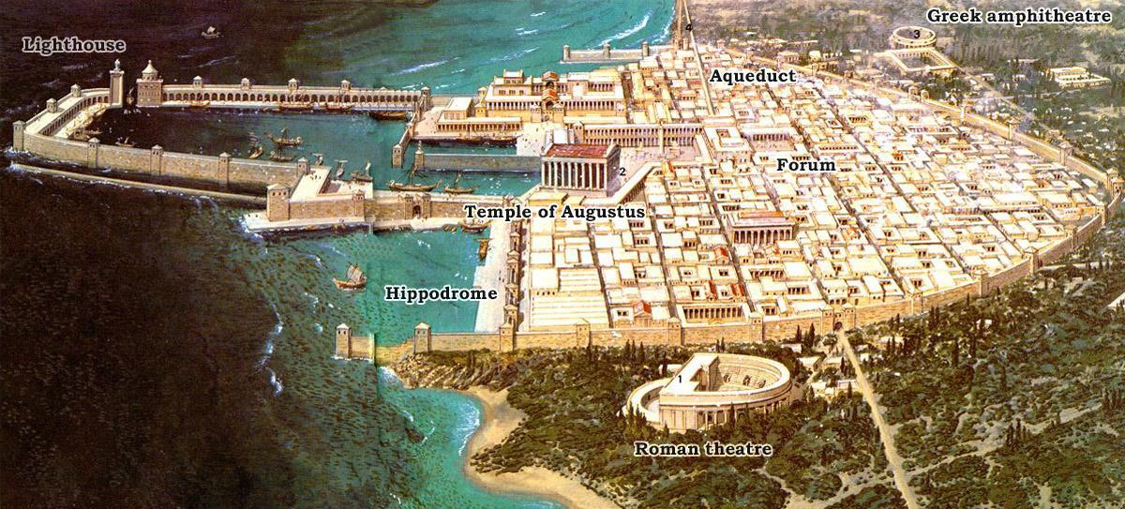
Reconstruction of Caesarea Maritima as it looked around the 1st or 2nd century AD; the city was built by Herod the Great during 25-13 BC, it was named in honor of Augustus Caesar and it served as the provincial capital of Judea, reaching a population of 100.000, larger than Jerusalem. Below is what it looks like today.
