10 ¹For since the law has but a shadow of the good things to come instead of the true form of these realities, it can never, by the same sacrifices that are continually offered every year, make perfect those who draw near. ² Otherwise, would they not have ceased to be offered, since the worshipers, having once been cleansed, would no longer have any consciousness of sins? ³ But in these sacrifices there is a reminder of sins every year. ⁴ For it is impossible for the blood of bulls and goats to take away sins.
⁵ Consequently, when Christ came into the world, he said, [in Psalm 40:6-8]
“Sacrifices and offerings you have not desired,
but a body have you prepared for me;
⁶ in burnt offerings and sin offerings
you have taken no pleasure.
⁷ Then I said, ‘Behold, I have come to do your will, O God,
as it is written of me in the scroll of the book.’”
⁸ When he said above, “You have neither desired nor taken pleasure in sacrifices and offerings and burnt offerings and sin offerings” (these are offered according to the law), ⁹ then he added, “Behold, I have come to do your will.” He does away with the first in order to establish the second. ¹⁰ And by that will we have been sanctified through the offering of the body of Jesus Christ once for all.
¹¹ And every priest stands daily at his service, offering repeatedly the same sacrifices, which can never take away sins. ¹² But when Christ had offered for all time a single sacrifice for sins, he sat down at the right hand of God, ¹³ waiting from that time until his enemies should be made a footstool for his feet. ¹⁴ For by a single offering he has perfected for all time those who are being sanctified.
¹⁵ And the Holy Spirit also bears witness to us; for after saying, [in Jeremiah 31:33]

¹⁶ “This is the covenant that I will make with them
after those days, declares the Lord:
I will put my laws on their hearts,
and write them on their minds,”
¹⁷ then he adds, [in Jeremiah 31:34]
“I will remember their sins and their lawless deeds no more.”
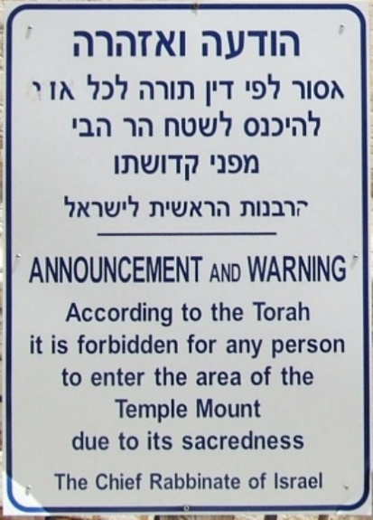
¹⁸ Where there is forgiveness of these, there is no longer any offering for sin.
¹⁹ Therefore, brothers, since we have confidence to enter the holy places by the blood of Jesus, ²⁰ by the new and living way that he opened for us through the curtain, that is, through his flesh, ²¹ and since we have a great priest over the house of God, ²² let us draw near with a true heart in full assurance of faith, with our hearts sprinkled clean from an evil conscience and our bodies washed with pure water.

Statements in the Psalms quoted the New Testament that explicitly refer to Christ
• “You are my Son; today I have become your Father” (Ps 2:7; Acts 13:33).
• “You put everything under his feet” (Ps 8:6; Hebrews 2:6–10).
• “Because you will not abandon me to the grave, nor will you let your Holy One see decay” (Ps 16:10; Acts 2:27).
• “My God, my God, why have you forsaken me?” (Ps 22:1; Matthew 27:46).
• “He trusts in the LORD; let the LORD rescue him.” (Ps 22:8; Matthew 27:43).
• “They have pierced my hands and feet” (Ps 22:16; John 20:25).
• “They divide my garments among them and cast lots for my clothing” (Ps 22:18; John 19:24).
• “Here I am, I have come … to do your will, O my God” (Ps 40:7–8; Hebrews 10:7).
• “Even my close friend, whom I trusted, he who shared my bread, has lifted up his heel against me”
(Ps 41:9; John 3:18).
• “Your throne, O God, will last for ever and ever” (Ps 45:6; Hebrews 1:8).
• “Zeal for your house consumes me” (Ps 69:9; John 2:17).
• “They put gall in my food and gave me vinegar for my thirst” (Ps 69:21; Matthew 27:34, 48).
• “May another take his place of leadership” (Ps 109:8; Acts 1:20).
• “the LORD says to my Lord: ‘Sit at my right hand until I make your enemies a footstool for your feet’ ”
(Ps 110:1; Matthew 22:44).
• “The LORD has sworn and will not change his mind: ‘You are a priest forever, in the order of Melchizedek’ ”
(Ps 110:4; Hebrews 7:17).
• “The stone the builders rejected has become the capstone” (Ps 118:22; Matthew 21:42).
• “Blessed is he who comes in the name of the LORD” (Ps 118:26; Matthew 21:9).

