11 ³² And what more shall I say? For time would fail me to tell of
Gideon,
Barak,
Samson,
Jephthah, of
David and
Samuel and the
prophets—
³³ who through faith
conquered kingdoms,
enforced justice,
obtained promises,
stopped the mouths of lions,
³⁴ quenched the power of fire,
escaped the edge of the sword,
were made strong out of weakness,
became mighty in war,
put foreign armies to flight.
³⁵ Women received back their dead by resurrection.
Some were tortured, refusing to accept release,
so that they might rise again to a better life.
³⁶ Others suffered mocking and flogging, and
even chains and imprisonment.
³⁷ They were stoned,
they were sawn in two,
they were killed with the sword.
They went about in skins of sheep and goats,
destitute, afflicted, mistreated—
³⁸ of whom the world was not worthy—wandering about in deserts and mountains, and in dens and caves of the earth.
³⁹ And all these, though commended through their faith, did not receive what was promised, ⁴⁰ since God had provided something better for us, that apart from us they should not be made perfect.
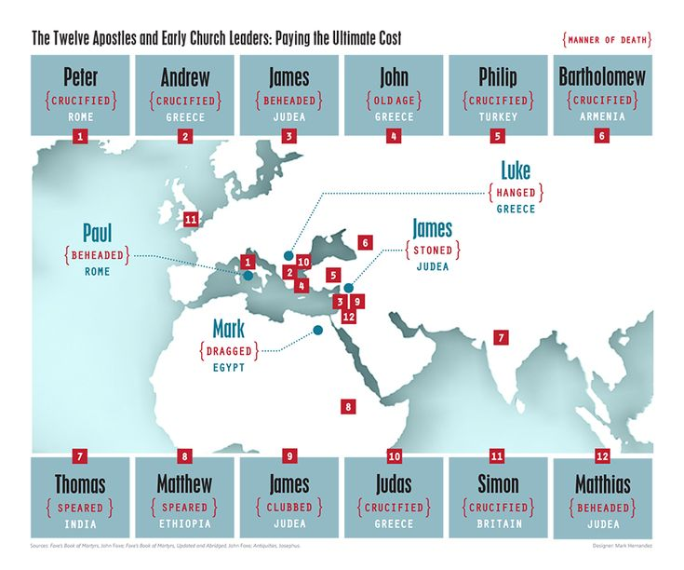
The Fate of the 12 Apostles (According to Tradition)
James, son of Zebedee: Beheaded with a sword by King Herod Agrippa I in Jerusalem (c. 44 AD).
Andrew: Crucified on an X-shaped cross in Patras, Greece (c. 60 AD).
Peter: Crucified upside down in Rome (c. 64-67 AD).
James, son of Alphaeus: Stoned and clubbed to death in Jerusalem (c. 60s AD).
Philip: possibly crucified or stoned in Hierapolis (modern Turkey).
Bartholomew (Nathanael): Flayed alive and then beheaded in Armenia (tradition).
Thomas (Didymus): Stabbed with a spear in India.
Matthew (Levi): Martyred by sword in Ethiopia (or Persia).
Thaddeus (aka Judas): Martyred (arrows or club) in Armenia/Persia (Iran).
Simon the Zealot: Martyred (possibly sawed in half) in Persia or Britain.
Matthias (Judas's replacement): Stoned and then beheaded (Syria/Cappadocia).
John (son of Zebedee): Exiled to Patmos, died a natural death in Ephesus (Turkey) as an old man (after 98 AD).

