1 ¹ Paul,
a servant of God and an apostle of Jesus Christ,
for the sake of the faith of God's elect and their knowledge of the truth,
which accords with godliness,
² in hope of eternal life,
which God,
who never lies,
promised before the ages began ³ and
at the proper time manifested in his word
through the preaching with which I have been entrusted
by the command of God our Savior;
⁴ To Titus, my true child in a common faith:
Grace and peace from God the Father and Christ Jesus our Savior.
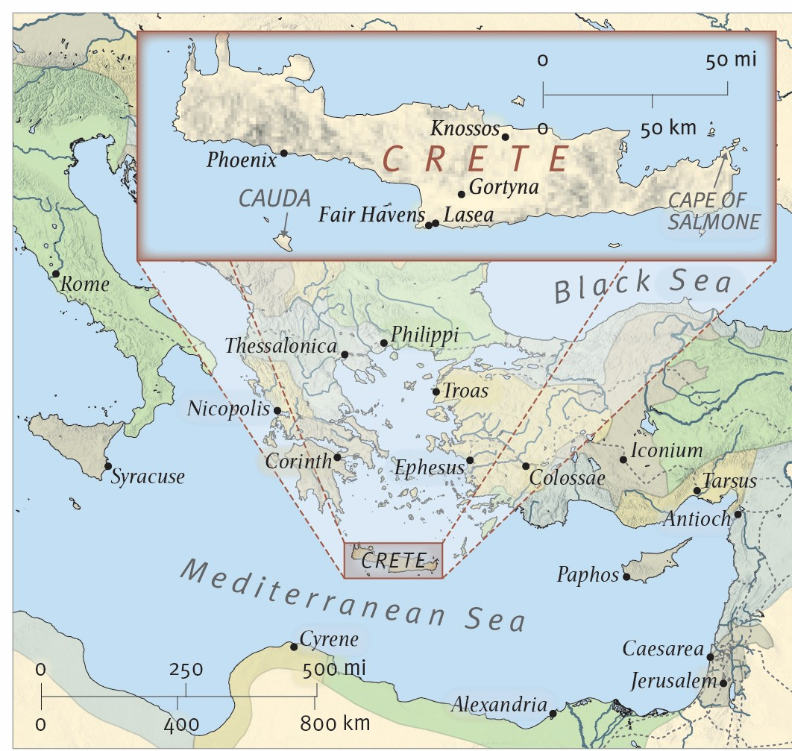
From the ESV® Study Bible (The Holy Bible, English Standard Version®), copyright ©2008 by Crossway, a publishing ministry of Good News Publishers. Used by permission. All rights reserved.

