1 ⁵ This is why I left you in Crete, so that you might put what remained into order,
and appoint elders (presbyteros) in every town as I directed you—
⁶ if anyone is above reproach (anenklētos),
the husband of one wife, and
his children are believers and
not open to the charge of debauchery or insubordination.
⁷ For an overseer (episkopos), as God's steward,
must be above reproach (anenklētos). He
must not be arrogant or quick-tempered or a drunkard or violent or greedy for gain,
⁸ but hospitable (philoksenon),
a lover of good (philagathon),
self-controlled,
upright, holy, and disciplined. ⁹ He
must hold firm to the trustworthy word as taught,
so that he may be able to give instruction in sound doctrine
and also to rebuke those who contradict it.
¹⁰ For there are many who are
insubordinate,
empty talkers (mataiologos) and deceivers,
especially those of the circumcision party.
¹¹ They must be silenced (epistomizō), since they are upsetting whole families
by teaching for shameful gain what they ought not to teach.
¹² One of the Cretans, a prophet of their own, said,
“Cretans are always liars, evil beasts, lazy gluttons.” ¹³ This testimony is true.
Therefore rebuke them sharply, that they may be sound in the faith,
¹⁴ not devoting themselves to Jewish myths
and the commands of people who turn away from the truth.
¹⁵ To the pure, all things are pure,
but to the defiled and unbelieving, nothing is pure;
but both their minds and their consciences are defiled.
¹⁶ They profess to know God, but they deny him by their works.
They are detestable, disobedient, unfit for any good work.
Greek Words at a Glance

presbyteros — elder; “presbyterian” (v.5)
anenklētos — above reproach, unaccusable (v.6, 7)
episkopos — overseer; “episcopal” (v.7)

philoksenon – a lover of stranger (v.8)
philagathon – a lover of good (v.8)
mataiologos — empty talker; “vain-speaker” (v.10)
epistomizō — to muzzle, stop the mouth (v.11)

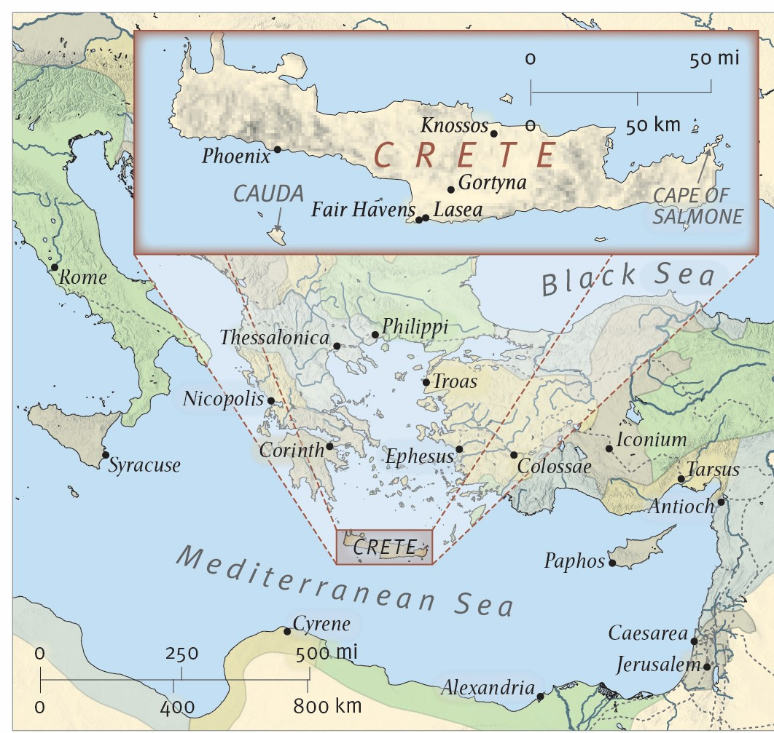
From the ESV® Study Bible (The Holy Bible, English Standard Version®), copyright ©2008 by Crossway, a publishing ministry of Good News Publishers. Used by permission. All rights reserved.

