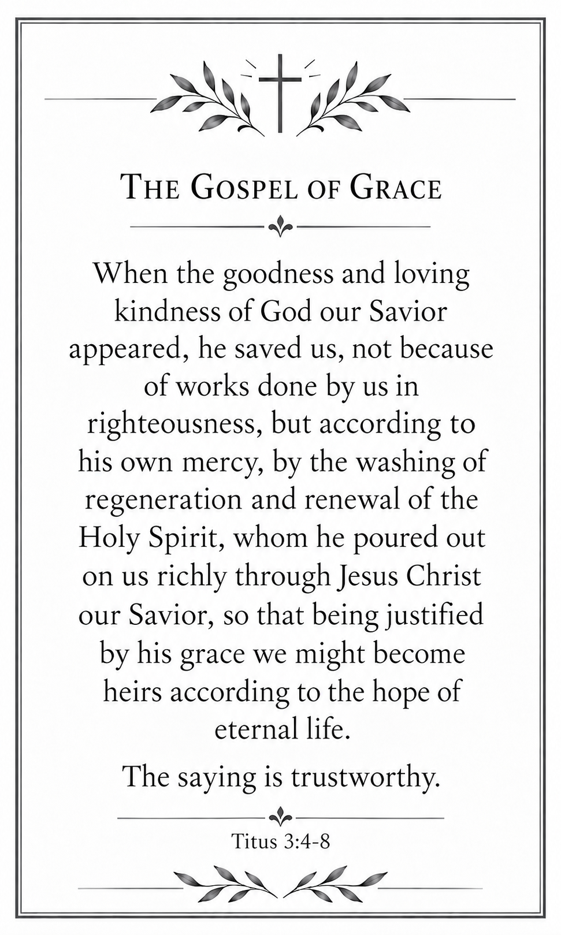
Systematic Theology found in Titus 3:4-7

The Doctrine of God: His Person and Attributes
God our Savior is the Father, who rescues sinners through his Son.
Loving Kindness is God’s tender, compassionate love toward people.
Mercy is God’s compassion toward sinners who deserve judgment.
Grace is God’s freely given favor toward undeserving sinners.
The Doctrine of Christ: His Person and Work
Jesus Christ our Savior is God’s Son, who died and rose to redeem us.
Justified means declared righteous by God through faith alone in Christ.
The Doctrine of the Holy Spirit: His Person and Work
Holy Spirit refers to God, the third person of the Trinity.
Regeneration is the Holy Spirit’s act of giving us new spiritual life.
Poured means God gave the Holy Spirit freely and abundantly.
Renewing is the Holy Spirit’s work of transforming our hearts and lives.
The Doctrine of Salvation: Its Basis and Application
Saved means to be rescued from sin and eternal condemnation.
Righteousness is conformity to God’s holy character and commands.
Washing is the spiritual cleansing from sin that God provides in salvation.
Heirs are God’s children who will receive his promised inheritance.
Works are the actions we perform, which cannot earn salvation.
The Doctrine of Last Things: Our Eternal Hope
Eternal Life is everlasting fellowship with God through Jesus Christ.

